🔥 Queue – Methods (Industry-Focused)
👉 In real-time projects, we mainly use safe methods
(because they don’t throw exceptions unnecessarily)

✅ MOST USED METHODS (🔥 Important)
1. offer(E e)
👉 Adds element to queue
queue.offer("A");
✔ Returns true/false
✔ Safe (no exception)

2. poll()
👉 Removes and returns head
queue.poll();
✔ Returns element
✔ Returns null if empty (safe)

3. peek()
👉 Returns head without removing
queue.peek();
✔ Returns element
✔ Returns null if empty (safe)

⚠ Less Used (Exception-Based Methods)
👉 These are rarely used in industry because they throw exceptions

4. add(E e)
👉 Similar to offer()
❌ Throws exception if fails

5. remove()
👉 Similar to poll()
❌ Throws NoSuchElementException if empty

6. element()
👉 Similar to peek()
❌ Throws NoSuchElementException if empty

🔥 PriorityQueue (Very Simple + Complete Explanation)
✅ What is PriorityQueue?
👉 PriorityQueue is a class that implements the Queue interface
➡️ It extends AbstractQueue
public class PriorityQueue<E> extends AbstractQueue<E> implements Serializable { }
👉 Introduced in JDK 1.5

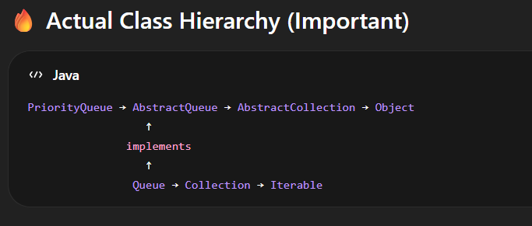

🔥 How it works?
👉 It does NOT follow FIFO
👉 It processes elements based on priority
- Default → Natural sorting order (ascending)
- Custom → using Comparator

🔥 Properties of PriorityQueue
- 👉 ❌ Does NOT follow insertion order
- 👉 ✔ Follows priority-based ordering (heap structure)
- 👉 Stores elements based on declaration:
  - ✔ With generics → homogeneous
  - ⚠ Without generics → heterogeneous (not recommended, may cause ClassCastException)
- 👉 ✔ Allows duplicate elements
- 👉 ❌ Does NOT allow null values (NullPointerException)
- 👉 ❌ Not synchronized
- 👉 ❌ Not thread-safe
- 👉 ⚠ No guarantee of strict ordering when iterating
(only head element is guaranteed)

✅ Most Commonly Used in Real-Time Projects
1. PriorityQueue()
👉 Very frequently used
- Default behavior (min-heap)
- Natural ordering (numbers → smallest first, strings → alphabetical)
PriorityQueue<Integer> pq = new PriorityQueue<>();
pq.add(10);
pq.add(5);
pq.add(20);
System.out.println(pq.poll()); // 5
✔ Used when:
- You just need sorting by default priority
- Simple use cases (top K elements, scheduling, etc.)

2. PriorityQueue(Comparator c)
👉 Most important in industry
This is used heavily in real-time systems.
PriorityQueue<Integer> pq = new PriorityQueue<>((a, b) -> b - a); // max heap
pq.add(10);
pq.add(5);
pq.add(20);
System.out.println(pq.poll()); // 20
✔ Used when:
- Custom sorting needed
- Complex objects (Employee, Student, Orders)
- Real-time systems like:
  - Task scheduling
  - Event processing
  - Job priority systems

3. PriorityQueue(int capacity, Comparator c)
👉 Used in performance-critical systems
PriorityQueue<Integer> pq = new PriorityQueue<>(50, (a, b) -> b - a);
✔ Used when:
- You know expected size
- Want to avoid resizing overhead
- High-performance systems (large-scale apps)

⚖️ Occasionally Used
4. PriorityQueue(int capacity)
👉 Rarely used alone
- Capacity grows automatically anyway
- Not very useful unless optimizing memory

5. PriorityQueue(Collection c)
👉 Sometimes used
List<Integer> list = Arrays.asList(10, 5, 20);
PriorityQueue<Integer> pq = new PriorityQueue<>(list);
✔ Used when:
- You already have data
- Want quick heap creation

❌ Rarely Used in Industry
6. PriorityQueue(SortedSet ss)
👉 Almost never used
- Because you can directly use collection constructor

7. PriorityQueue(PriorityQueue pq)
👉 Very rare
- Copying queues is uncommon
- Usually handled differently
🔥 ONLY Most Used PriorityQueue Methods (Industry Reality)
✅ 1. offer()
👉 Insert element (MOST USED)
pq.offer(task);
✔ Preferred over add()
✔ Safe (no exception if capacity issues)
✔ Used in:
- Job queues
- Event systems
- Scheduling systems

✅ 2. poll()
👉 Remove + get highest priority element
Task task = pq.poll();
✔ Returns null if empty
✔ Used in every real-time processing loop

✅ 3. peek()
👉 Check next element without removing
Task next = pq.peek();
✔ Used when:
- You want to decide before processing
- Scheduling logic (check next execution time)

✅ 4. isEmpty()
👉 Check if queue has elements
while (!pq.isEmpty()) {
process(pq.poll());
}
✔ Used in almost every loop

✅ 5. size()
👉 Queue size monitoring
if (pq.size() > 1000) {
// scaling / alert logic
}
✔ Used in:
- Monitoring
- Load handling

❌ NOT Common in Real Projects
🚫 add()
- Works same as offer()
- But less preferred in production code

🚫 remove()
- Throws exception → risky
- Avoided in real-time systems

🚫 contains()
- O(n) → slow
- Not suitable for high-performance systems

🔥 REAL INDUSTRY PATTERN (VERY IMPORTANT)
This is how PriorityQueue is actually used in backend systems:
while (!pq.isEmpty()) {
Task task = pq.poll(); // get highest priority
process(task);
}
OR
if (pq.peek().getTime() <= currentTime) {
process(pq.poll());
}
👉 This pattern is used in:
- Task schedulers
- Message queues
- Event-driven systems

🧠 Final Answer (What You Should Remember)
⭐ 90% Industry Usage = Only These 4
👉 offer()
👉 poll()
👉 peek()
👉 isEmpty()

⭐ Optional (sometimes)
👉 size()

❌ Ignore for real-time focus

Array representation of binary tree
🔷 Step 1: Take a Random Unsorted Array
[50, 10, 70, 5, 20, 60]
👉 No sorting
👉 No min/max rule
👉 Just a normal array

🔷 Step 2: Treat Array as Binary Tree
We assume:
👉 Index = position in tree
👉 We map it using formulas

🔷 Core Mapping Formula (VERY IMPORTANT)
For index i:
$$\text{Left child}=2i+1,\text{Right child}=2i+2,\text{Parent}=\left\lfloor \frac{i-1}{2}\right\rfloor$$

🔷 Step 3: Build Tree from Array
Now we place elements based on index:
Index: 0 1 2 3 4 5
Value: 50 10 70 5 20 60

🌳 Tree Representation
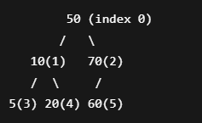

🔷 Step 4: Verify Using Formula
Let’s check one node to confirm:

👉 Node at index 1 → value = 10
- Left → 2*1+1 = 3 → 5
- Right → 2*1+2 = 4 → 20
✔ Correct

👉 Node at index 2 → value = 70
- Left → 2*2+1 = 5 → 60
- Right → 2*2+2 = 6 → ❌ not present
✔ Correct

🔷 Step 5: Important Clarification (Your Doubt)
👉 This is NOT BST
Why?
BST rule:
- Left < Root < Right
Check here:
- Left of 50 → 10 ✔
- Right of 50 → 70 ✔
BUT:
- Left of 10 → 5 ✔
- Right of 10 → 20 ✔
BUT:
- Left of 70 → 60 ❌ (should be >70 for BST)
👉 So this is:
✔ Binary Tree
❌ Not BST
❌ Not Heap

🔷 Step 6: Key Understanding
👉 When we say:
“Array Representation of Binary Tree”
It means:
- Take array as-is
- Map indices to tree
- No sorting
- No reordering

🔥 Final Summary
👉 Input array:
[50, 10, 70, 5, 20, 60]
👉 Becomes tree using index mapping:
- Root → index 0
- Left → 2i+1
- Right → 2i+2
👉 No sorting involved
👉 Not necessarily BST or Heap

🔷 1. What is a Complete Binary Tree?
👉 A Complete Binary Tree is a tree where:
✔ All levels are completely filled
✔ Except possibly the last level
✔ Last level is filled from left to right (no gaps)

🔷 1. What is a Complete Binary Tree?
👉 A Complete Binary Tree is a tree where:
✔ All levels are completely filled
✔ Except possibly the last level
✔ Last level is filled from left to right (no gaps)

🔷 2. Visual Understanding
✅ Valid Complete Binary Trees
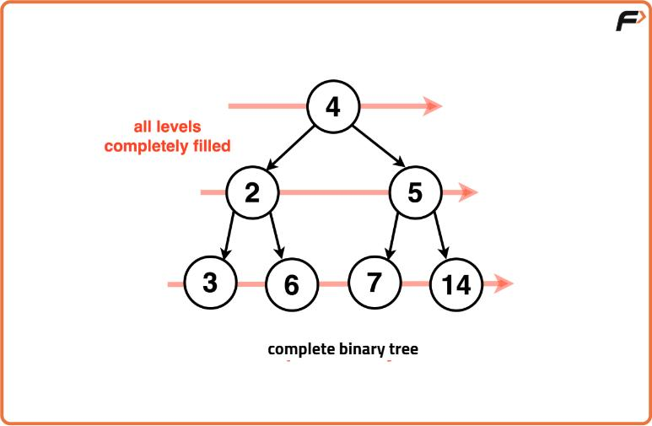
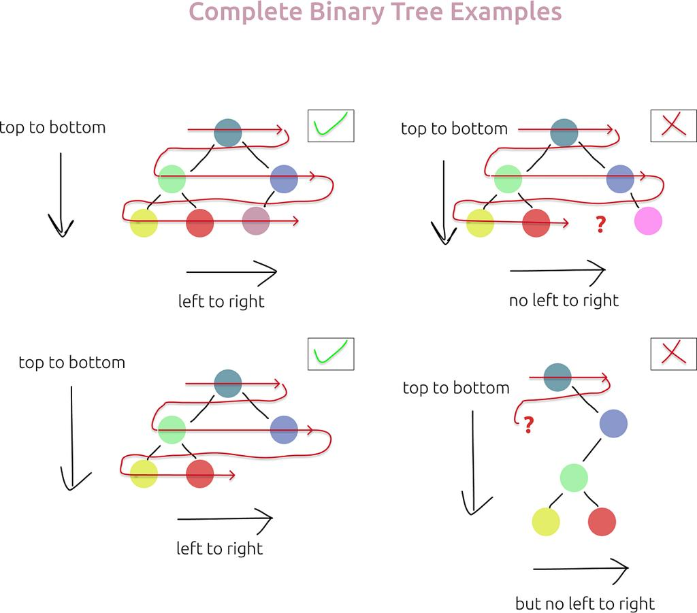

6
Example:
10
/ \
20 30
/ \ /
40 50 60
✔ Last level is filled left → right
✔ No gaps in between

❌ NOT Complete Binary Tree
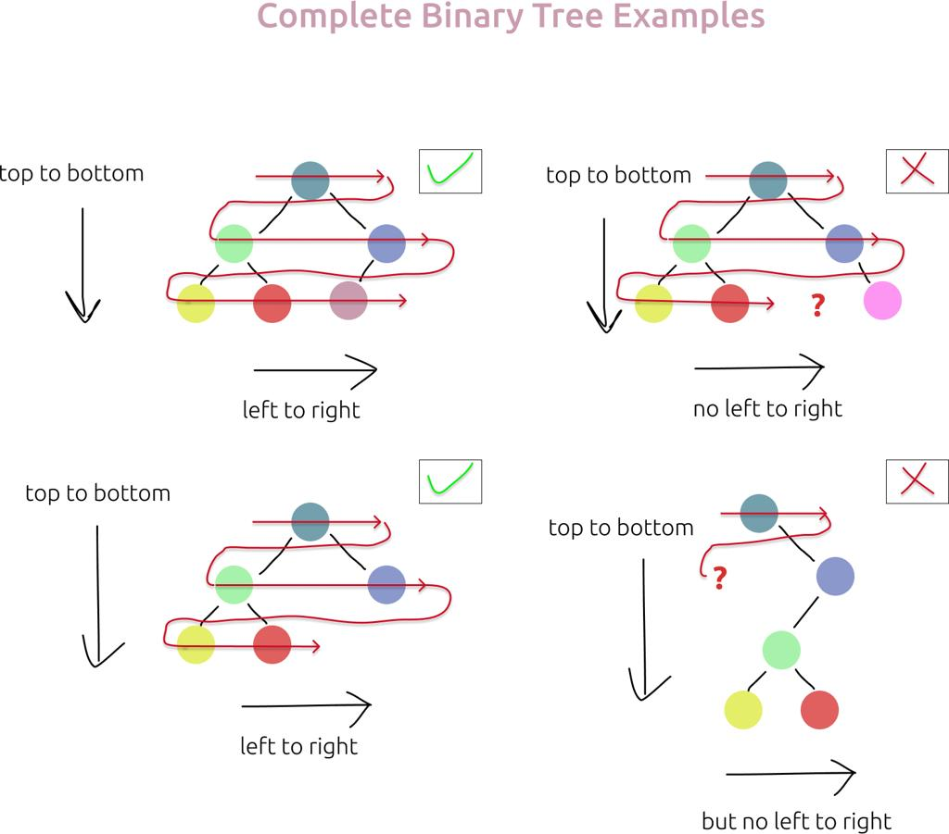

7
Example:
10
/ \
20 30
\ \
50 60
❌ Gap on left side
❌ Not filled left to right

🔷 3. Simple Rule to Remember
👉 “No gaps allowed before the last node”
or
👉 Fill nodes like a queue (left to right)

🔷 4. Why Complete Binary Tree is IMPORTANT?
🔥 This is the backbone of:
- Heap
- Priority Queue
Because:
👉 It allows array representation without waste

🔷 5. CBT + Array Representation Connection
Take this tree:
50
/ \
10 70
/ \ /
5 20 60
Array:
[50, 10, 70, 5, 20, 60]
👉 Notice:
✔ No empty spaces
✔ Continuous indices

❌ If NOT Complete
50
/
10
\
20
Array becomes:
[50, 10, null, null, 20]
❌ Wasted space
❌ Inefficient

Min Heap:
🔷 Given Array
[50, 10, 70, 5, 20, 60]

🔷 Initial Tree (using 2i+1, 2i+2)
50 (0)
/ \
10 (1) 70 (2)
/ \ /
5 (3) 20 (4) 60 (5)

🔷 Step 1: i = 2 (value = 70)
👉 Formula:
- Left = 2*2+1 = 5 → 60
Before
50
/ \
10 70
/ \ /
5 20 60
👉 70 > 60 → swap

After
50
/ \
10 60
/ \ /
5 20 70
Array:
[50, 10, 60, 5, 20, 70]

🔷 Step 2: i = 1 (value = 10)
👉 Formula:
- Left = 3 → 5
- Right = 4 → 20
Before

50
/ \
10 60
/ \ /
5 20 70
👉 smallest = 5 → swap

After
50
/ \
5 60
/ \ /
10 20 70
Array:
[50, 5, 60, 10, 20, 70]

🔷 Step 3: i = 0 (value = 50)
👉 Formula:
- Left = 1 → 5
- Right = 2 → 60
Before
50
/ \
5 60
/ \ /
10 20 70
👉 smallest = 5 → swap

After (first swap)
5
/ \
50 60
/ \ /
10 20 70
Array:
[5, 50, 60, 10, 20, 70]

🔷 Continue Heapify (IMPORTANT)
Now node = 50 (index 1)
👉 Formula:
- Left = 3 → 10
- Right = 4 → 20

Before
5
/ \
50 60
/ \ /
10 20 70
👉 smallest = 10 → swap

Final Tree
5
/ \
10 60
/ \ /
50 20 70
Array:
[5, 10, 60, 50, 20, 70]

🔷 Final Verification (Formula)
Check root (index 0):
- Left = 1 → 10
- Right = 2 → 60
✔ 5 ≤ 10, 60

🔥 Final Clarity
👉 Every step =
✔ Use formula → find children
✔ Compare → swap
✔ Reflect in tree + array

💡 One-line memory
👉 Heapify = fix tree node-by-node using index formulas

